 Cannon River Canoe Trip (Half-day)

PREPARATION
- At least one adult leader must take the on-line Safety Afloat training through my.scouting.org
- Everyone on the trip must wear a Personal Floatation Device (PFD) at all times.
- Canoes can be rented at Phillipo Scout Camp through the Northern Star Council website. Canoe rental is $15 per canoe per day, including paddles and PFDs. Canoe trailer rental is $25 per day. When renting a trailer, the unit needs to rent at least half of the trailer full of canoes, to insure there are enough trailers for others that need canoes. Trailers hold up to 6 canoes.
- Swimming Ability – Every participant who intends to train for or paddle a solo kayak or canoe at a Scouting function must be classified as a swimmer by completing the 100-yard BSA swimmer classification test. For activity afloat, those not classified as swimmers are limited to multi-person craft during outings or float trips on calm water with little likelihood of capsizing or falling overboard. They may ride as a buddy in a tandem paddlecraft with an adult swimmer skilled in that craft.
- Canoeing Ability - Participants should have basic canoeing skills before paddling down rivers. Even if your troop is not camping at a Council camp, you may be able to rent the canoes there to practice on a local lake.
- Float Plan - Before Scouts go afloat, they develop a float plan detailing their route, time schedule, and contingency plans and share it with someone not on the trip. The float plan considers all possible water and weather conditions and all applicable rules or regulations, and is shared with all who have an interest.
- Water Levels - Most springs, the water level can be quite high. During normal water levels, the Cannon River flows 1 - 3 mph. During high water, it can also get pretty fast (~6mph). There are occasionally tree limbs sticking into the river. These can be dangerous for inexperienced canoers. Consider scheduling trips when the water is not high.

THE TRIP
- Meet at Phillipo Scout Camp. You can reserve overnight camping or cabins through the Northern Star Council website.
- At least one vehicle will have to be left at Phillipo Scout Camp so plan your rides accordingly.
- One vehicle must be capable of pulling the trailer loaded with canoes.
- Turn right at the camp gate on 310th Street. Turn left on MN Highway 56 South. Turn right on 320th Street. Turn right on Canada Ave. and park at the Waterford Historic Bridge. This is the old silver bridge that is closed. You can park near the bridge and put in the canoes there.(approximately river mile 39)
- The takeout is at Phillipo Scout Camp on the right shoreline of Lake Byllesby

MORE INFORMATION ON THE CANNON RIVER
https://www.dnr.state.mn.us/watertrails/cannonriver/index.html

Avenza Maps is a very nice free off-line mapping program which can download the same maps as above. After downloading the application and maps, a data connection is no longer needed. After downloading the Avenza program, you need to click on the ‘Store’ link in the app, and search for the map: Cannon River State Water Trail.

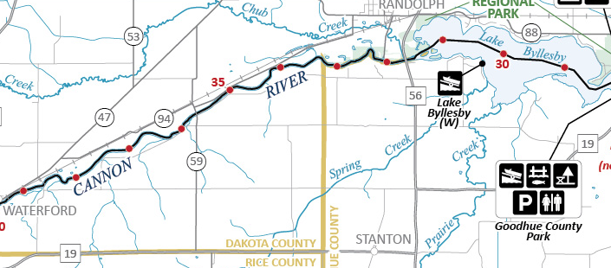



Cannon River Canoe Trip (Full day)

PREPARATION
- At least one adult leader must take the on-line Safety Afloat training through my.scouting.org
- Everyone on the trip must wear a Personal Floatation Device (PFD) at all times.
- Canoes can be rented at Phillipo Scout Camp through the Northern Star Council website. Canoe rental is $15 per canoe per day, including paddles and PFDs. Canoe trailer rental is $25 per day. When renting a trailer, the unit needs to rent at least half of the trailer full of canoes, to insure there are enough trailers for others that need canoes. Trailers hold up to 6 canoes.
- Swimming Ability – Every participant who intends to train for or paddle a solo kayak or canoe at a Scouting function must be classified as a swimmer by completing the 100-yard BSA swimmer classification test. For activity afloat, those not classified as swimmers are limited to multi-person craft during outings or float trips on calm water with little likelihood of capsizing or falling overboard. They may ride as a buddy in a tandem paddlecraft with an adult swimmer skilled in that craft.
- Canoeing Ability - Participants should have basic canoeing skills before paddling down rivers. Even if your troop is not camping at a Council camp, you may be able to rent the canoes there to practice on a local lake.
- Float Plan - Before Scouts go afloat, they develop a float plan detailing their route, time schedule, and contingency plans and share it with someone not on the trip. The float plan considers all possible water and weather conditions and all applicable rules or regulations, and is shared with all who have an interest.
- Water Levels - Most springs, the water level can be quite high. During normal water levels, the Cannon River flows 1 - 3 mph. During high water, it can also get pretty fast (~6mph). There are occasionally tree limbs sticking into the river. These can be dangerous for inexperienced canoers. Consider scheduling trips when the water is not high.

MORE INFORMATION ON THE CANNON RIVER
https://www.dnr.state.mn.us/watertrails/cannonriver/index.html

Avenza Maps is a very nice free off-line mapping program which can download the same maps as above. After downloading the application and maps, a data connection is no longer needed. After downloading the Avenza program, you need to click on the ‘Store’ link in the app, and search for the map: Cannon River State Water Trail.

THE TRIP
- Meet at Phillipo Scout Camp. You can reserve overnight camping or cabins through the Northern Star Council website.
- At least one vehicle will have to be left at Phillipo Scout Camp so plan your rides accordingly.
- One vehicle must be capable of pulling the trailer loaded with canoes.
- Turn right at the camp gate on 310th Street. Turn left on MN Highway 56 South. Turn right on MN Highway West. Turn right on 2nd Street. Turn left on Dahomey Ave. Continue straight on MN Highway 3. Turn right on Hester Street. Turn left on Railway Street to Mill Park (101 Railway Street South). You can park and put in the canoes there.(approximately river mile 45)
- You will need to portage left around the Northfield Dam along the road, there is no portage trail.
- The takeout is at Phillipo Scout Camp on the right shoreline of Lake Byllesby

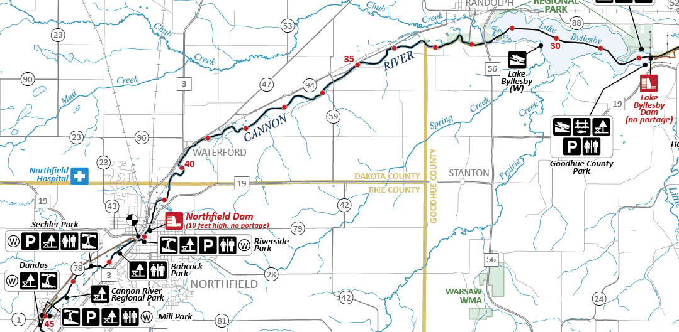

Cannon River Canoe Trip (overnight)

PREPARATION
- At least one adult leader must take the on-line Safety Afloat training through my.scouting.org
- Everyone on the trip must wear a Personal Floatation Device (PFD) at all times.
- Canoes can be rented at Phillipo Scout Camp through the Northern Star Council website. Canoe rental is $15 per canoe per day, including paddles and PFDs. Canoe trailer rental is $25 per day. When renting a trailer, the unit needs to rent at least half of the trailer full of canoes, to insure there are enough trailers for others that need canoes. Trailers hold up to 6 canoes.
- Swimming Ability – Every participant who intends to train for or paddle a solo kayak or canoe at a Scouting function must be classified as a swimmer by completing the 100-yard BSA swimmer classification test. For activity afloat, those not classified as swimmers are limited to multi-person craft during outings or float trips on calm water with little likelihood of capsizing or falling overboard. They may ride as a buddy in a tandem paddlecraft with an adult swimmer skilled in that craft.
- Canoeing Ability - Participants should have basic canoeing skills before paddling down rivers. Even if your troop is not camping at a Council camp, you may be able to rent the canoes there to practice on a local lake.
- Float Plan - Before Scouts go afloat, they develop a float plan detailing their route, time schedule, and contingency plans and share it with someone not on the trip. The float plan considers all possible water and weather conditions and all applicable rules or regulations, and is shared with all who have an interest.
- Water Levels - Most springs, the water level can be quite high. During normal water levels, the Cannon River flows 1 - 3 mph. During high water, it can also get pretty fast (~6mph). There are occasionally tree limbs sticking into the river. These can be dangerous for inexperienced canoers. Consider scheduling trips when the water is not high.
- Potable Drinking Water is not available at these campsites. It is recommended to bring potable water rather than purifying river water.

MORE INFORMATION ON THE CANNON RIVER
https://www.dnr.state.mn.us/watertrails/cannonriver/index.html

Avenza Maps is a very nice free off-line mapping program which can download the same maps as above. After downloading the application and maps, a data connection is no longer needed. After downloading the Avenza program, you need to click on the ‘Store’ link in the app, and search for the map: Cannon River State Water Trail.

THE TRIP
- Meet at Phillipo Scout Camp. You can reserve overnight camping or cabins through the Northern Star Council website.
- At least one vehicle will have to be left at the takeout at the Waterford Historic so plan your rides accordingly.
- One vehicle must be capable of pulling the trailer loaded with canoes.
- Turn right at the camp gate on 310th Street. Turn left on MN Highway 56 South. Turn right on 320th Street. Turn right on Canada Ave. and leave one vehicle at the Waterford Historic Bridge. This is the old silver bridge that is closed. This is the takeout for your trip(approximately river mile 39).
- Proceed to the Two Rivers Park in Faribault (14th St NE, Faribault, MN) for the start of the trip(approximately river mile 59)
- The overnight campsites are the four campsites in the Cannon River Wilderness Area. The campsites are first-come, first-served with no reservations so you may have to canoe back and forth to find an open site that you like the best.
- You will need to portage left around the Northfield Dam along the road, there is no portage trail.
- The takeout is at the Waterford Historic Bridge where you left one vehicle.

